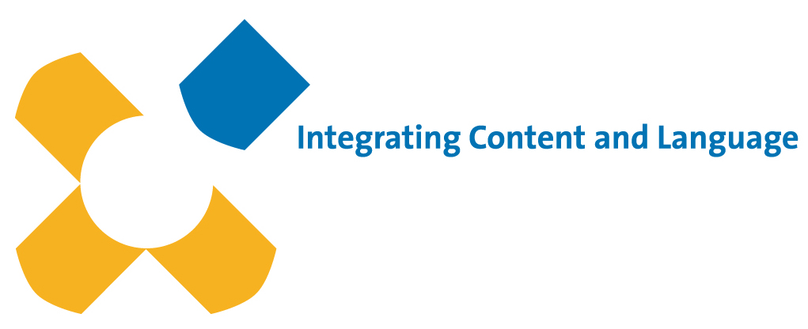
in Higher Education
Membership report 2018-2019
17th October 2019

ICLHE membership can be described as fairly solid at this point in time. Although the actual numbers of members fluctuates through the year, at the present time we have roughly the same number of members as at this time last year (literally a handful more members). It is typical that membership declines during the year and then increases again in the run-up to a conference or symposium, and that has been the case again this year. It is my feeling that the Association has a solid membership base, with the potential to grow in the coming years, assuming that the website and associated activities provide members with a strong sense of connection to the association. The more active members are in relation to the association, logically the more likely they are to continue to renew their membership and to persuade others to join. A positive step this year has been the outsourcing of website administration to Wild Teak. Wild Teak has carried out considerable work, together with our colleague Jennifer Valcke, to ensure that the systems and technical processes on which our membership procedures depend are reliable and transparent. This has made the tasks of the membership secretary more straightforward and I hope this means that my successor as I step down will be able to concentrate more on the recruitment of new members rather than administrative detail. I would like to thank the Association and my fellow Board members for the opportunity to work with them in an atmosphere of friendly collegiality, and I wish my successor every success in the role of membership secretary and I hope that ICLHE will continue to prosper in the coming years.
Kevin Haines, University of Groningen (NL)
Membership Secretary ICLHE
Contact: membership@iclhe.org

